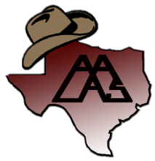
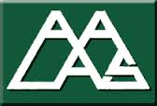
Calling all Animal Care Technicians!!!!
TBAALAS wants to send you to the 73rd National AALAS Meeting in Louisville, KY October 23rd- October 27th, 2022
What is the Technician Assistance Award?
This award is funded by TBAALAS to help support Laboratory Animal Technician’s to become more involved in Laboratory Science.
What does the Award Provide?
- Educational opportunities Learn a new technique or gain insight into the many different aspects of our industry to better yourself and the animals you care for
- $1600.00 towards your registration, airfare, lodging, and meals
- Networking Get to know people involved in your field
Qualifications for the Award
- Be an active TBAALAS member in good standing
- Has never attended a National AALAS meeting
Documentation Required
- Completed application
- A letter from your Director on institutional letterhead with the following information: Reasons why you deserve the award & a pledge of support stating that the nominee can accept the scholarship and will be able to attend that AALAS National meeting, if selected.
- 2 letters of support (recommended)
- Nomination letter

- All submissions will need to be received by December 30th, 2021
- Submit your application by email to:

Ryan Byrd
TBAALAS Education & Training Chair
ryan.byrd@bcm.edu

